Contraception, Sexual Health & Screening
A guide for patients
This leaflet gives an overview of contraceptive options, sexual health and STI protection, what to do if you miss a pill or an injection, and reminders about cervical screening and breast awareness. Your GP or practice nurse can talk through what suits you best.
Irelands free Contraception scheme covers the consultation, prescription and fitting for all women, girls and individuals with a uterus age 17-35 years (age range might be extended in future) Pills, patches, rings, hormone/copper coils and implants as well as the morning after pill.
Contraception — your options
All methods below are available through your GP or a family planning / sexual health clinic in Ireland. Effectiveness is highest with long-acting reversible contraception (LARC), as these don't rely on remembering a daily or weekly action.
Method | Type | How it works | Duration / notes
Contraceptive implant | LARC | Small rod under the skin of the upper arm; releases progestogen | Lasts 3 years. >99% effective
Hormonal coil (IUS) | LARC | Releases progestogen into the womb; thins the lining and thickens mucus | Lasts 5–8 years depending on type. Can reduce bleeding
Copper coil (IUD) | LARC | Non-hormonal; copper affects sperm and prevents implantation | Lasts 5–10 years. Can be used for emergency contraception
Contraceptive injection (Depo-Provera) | LARC | Progestogen injection given every 12–13 weeks | See missed injection rules overleaf
Combined pill (COC) | Short-acting | Daily tablet containing oestrogen and progestogen; stops ovulation | Taken daily. 91% effective with typical use
Progestogen-only pill (POP) | Short-acting | Daily tablet, no oestrogen; thickens cervical mucus | Must be taken at the same time each day — see missed pill rules
Contraceptive patch / vaginal ring | Short-acting | Combined hormones absorbed through skin or vaginal wall | Patch changed weekly; ring changed monthly
Male / female condoms | Barrier | Physical barrier prevents sperm reaching the egg | Single use. The only methods that also protect against STIs
Diaphragm / cap | Barrier | Silicone barrier placed over the cervix with spermicide | Used with each act of intercourse
Fertility awareness | Natural | Tracking cycle, temperature and mucus changes to identify fertile days | Requires training and consistency
Sterilisation (male or female) | Permanent | Surgical procedure to prevent pregnancy permanently | Intended to be irreversible

Sexual health & STIs
Sexually transmitted infections (STIs) such as chlamydia, gonorrhoea, genital warts, herpes and HIV are common and often cause no symptoms — you can carry and pass on an infection without knowing. Regular testing is recommended if you have a new partner, multiple partners, or have had unprotected sex.
- Free, confidential home STI testing (age 17+) is available at sexualwellbeing.ie — a kit is posted discreetly to your home.
- Free condoms and lubricant are also available through this service and many community venues.
- If you have symptoms (discharge, pain, sores, bleeding between periods), contact your GP or a sexual health clinic rather than home testing.
- Untreated STIs can affect fertility and general health — don't delay getting checked.
Why barrier protection matters
Condoms (male or female) are the only contraceptive method that also protects against STIs.
- Hormonal contraception, the coil, implant and sterilisation prevent pregnancy but do NOT protect against STIs.
If you're using another method for contraception, use condoms as well for STI protection — this is called ‘dual protection’.
Condoms should be used correctly and consistently and checked for the CE mark and expiry date.
Missed pill rules
Combined pill (COC)
These rules apply to standard combined pills taken in a 21/7 or similar regimen. If in doubt, treat it as a missed pill and use condoms.
If you have missed pills… | What to do
1 pill, anywhere in the pack (less than 72 hours since your last active pill) | Take the missed pill now, even if it means taking two in one day. Continue the rest of the pack as normal. No extra precautions needed.
2 or more pills, in week 1 (pills 1–7) | Take the most recent missed pill now. Use condoms or avoid sex for 7 days. Consider emergency contraception if you had unprotected sex in the pill-free week or week 1.
2 or more pills, in week 2 (pills 8–14) | Take the most recent missed pill now. Use condoms for 7 days. Emergency contraception is not usually needed if the previous 7 pills were taken correctly.
2 or more pills, in week 3 (pills 15–21) | Finish the active pills in your current pack (skip the pill-free break) and start a new pack the next day, OR take a break as usual — either way, use condoms for 7 days.
Progestogen-only pill (POP)
Type of POP | “Late” means | What to do
Levonorgestrel or norethisterone POP (e.g. Norgeston, Noriday) | More than 3 hours after your usual time | Take the missed pill as soon as you remember. Use condoms or avoid sex for 2 days.
Desogestrel POP (e.g. Cerazette, Cerelle) | More than 12 hours after your usual time | Take the missed pill as soon as you remember. Use condoms or avoid sex for 2 days.
Always consider emergency contraception if…
You've had unprotected sex and missed pills as above, particularly early in a pack or after a long gap.
The emergency contraceptive pill is available free from pharmacies, GPs and sexual health clinics — the sooner it's taken, the more effective it is.
The copper coil can also be used as emergency contraception up to 5 days after unprotected sex, fitted by your GP or clinic.

Missed contraceptive injection (Depo-Provera)
Depo-Provera is given every 12 weeks (13 weeks for the newer formulation). It has some built-in flexibility, but timing still matters:
Injection timing
- Up to and including 14 weeks since your last injection:
You can have your next injection with no additional contraceptive precautions needed.
- More than 14 weeks since your last injection:
Contact your GP or clinic. You may need a pregnancy test before the injection, and you should use condoms or avoid sex for 7 days after the injection is given.
If you've had unprotected sex since your injection was due, you may also need emergency contraception — ask your GP or nurse.
Tip: set a reminder in your phone for your next injection date, or ask the practice to text you a reminder.
Cervical screening — CervicalCheck
Don't forget your smear test
Free HPV cervical screening is available to all women and people with a cervix aged 25–65, through CervicalCheck.
Screening interval: every 3 years if you're aged 25–29; every 5 years if you're aged 30–65 (once results are normal).
You don't need to wait for a letter — if your test is due or overdue, contact your GP practice to book.
Screening looks for high-risk HPV, the virus responsible for most cervical cancers — it is not a test for cancer itself but helps prevent it.
Freephone CervicalCheck: 1800 45 45 55, or see cervicalcheck.ie
Breast awareness — checking your breasts
Being familiar with how your breasts normally look and feel makes it easier to notice changes. Most breast changes are not cancer, but any new change should be checked by your GP.
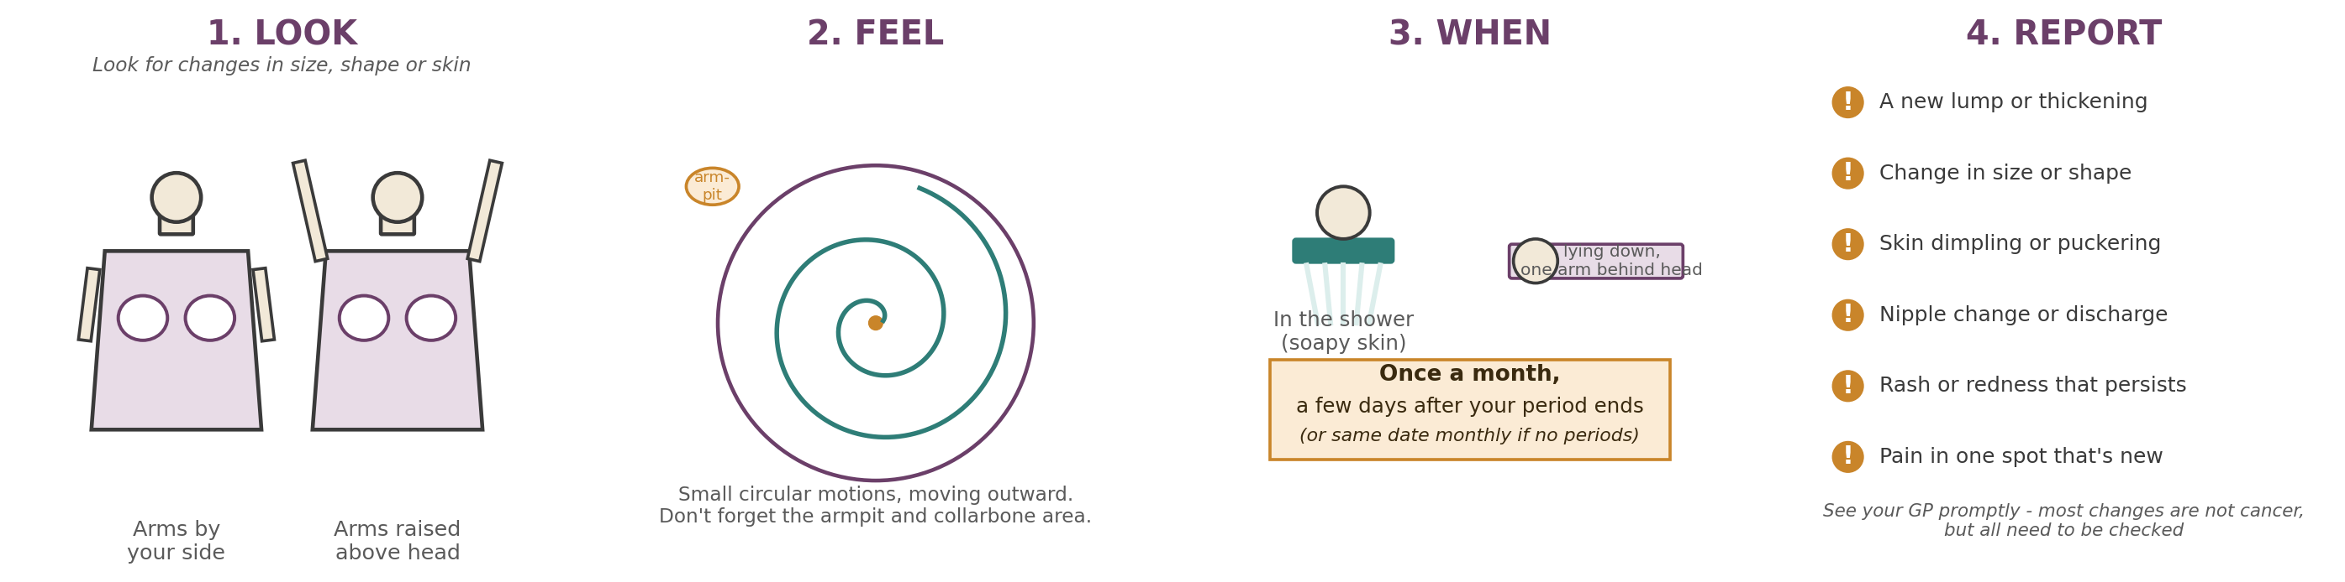
BreastCheck — national screening programme
Free mammograms every 2 years are offered to women aged 50–69 through BreastCheck — you'll be invited automatically once registered.
Breast awareness and self-checks are important at any age, alongside — not instead of — BreastCheck screening.
Freephone BreastCheck: 1800 45 45 55, or see breastcheck.ie
Useful contacts
- Free home STI testing & sexual health information: sexualwellbeing.ie
- CervicalCheck: 1800 45 45 55 — cervicalcheck.ie
- BreastCheck: 1800 45 45 55 — breastcheck.ie
- Your GP practice: for contraception advice, fitting of LARC methods, and any concerns about symptoms

