Living Well with Asthma
A quick reminder sheet— bring inhalers and your Asthma Action Plan to every review
Know Your Triggers
Asthma symptoms can be set off by many different things. Try to notice your own pattern and avoid or manage these where you can:
- Colds and respiratory infections  - Pollen, hay fever, grass and trees  - House dust mites, pet fur and feathers  - Cigarette smoke, vaping and air pollution | - Cold air, damp or humid weather  - Exercise or exertion  - Strong smells, sprays, cleaning products  - Stress and strong emotions
Don't forget work triggers
Dusts, fumes, chemicals, solvents, flour, wood dust, cleaning agents, or animal exposure at work can trigger or worsen asthma (occupational asthma). Tell your GP or nurse if your symptoms are better on days off or holidays — this may need specific assessment.
Understanding Your Airways
Asthma causes the airway lining to become inflamed and swollen, the muscle around the airway to tighten, and extra mucus to build up — narrowing the space air can move through.
 |  | 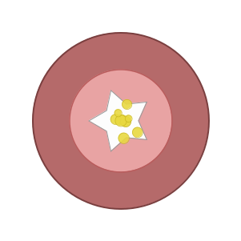
Normal airway | Asthma airway | During an asthma attack
Open airway, thin lining, easy airflow | Swollen lining, tighter muscle, some mucus | Very narrow airway, muscle squeezed tight, mucus plugging
Your Asthma Action Plan
Your action plan tells you what to do when you are well, when symptoms start to worsen, and what to do in an emergency — like a traffic light:
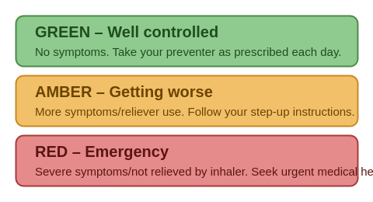
Bring these to EVERY review visit
✓ Your written Asthma Action Plan
✓ ALL of your inhalers (preventer, reliever, and MART/combination inhaler if you have one)
If you are on a MART plan
MART (Maintenance and Reliever Therapy) means you use one combination inhaler (containing both a preventer [ICS] and a fast-acting LABA) both every day AND for symptom relief — instead of separate preventer and reliever inhalers. Do not use a separate SABA reliever alongside MART unless your prescriber has told you to.
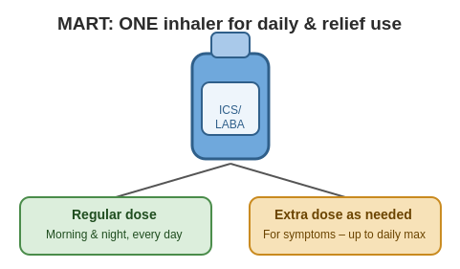
Always stay within the maximum number of puffs per day stated on your action plan. If you need more than this, contact your GP/practice nurse.
Using Your Peak Flow Meter at Home
If you don’t have a peak flow meter you can buy one for €15-€20 in your local chemist
- Stand or sit up straight  - Slide the marker to the bottom of the scale  - Take a full deep breath in  - For action plan to work out 80% divide personal best by 100 and times by 80. E.g. PB 500 - 500/100x80=400 | - Seal your lips tightly around the mouthpiece  - Blow out as hard and as fast as you can — one sharp blast  - Repeat 3 times and record the highest of the 3 readings
Know your "Best" (record best of 3 twice daily 2 weeks)
Your personal best peak flow is usually recorded when your asthma is well controlled, over a 2–3-week period. Write this number on your Asthma Action Plan — your green/amber/red zones are calculated as a percentage of this best reading, so it needs to be kept up to date.
Your Inhalers — Preventer vs Reliever
 | Preventer (usually inhaled steroid) | Reliever (usually SABA, e.g. salbutamol)
Purpose | Reduces airway inflammation over time — prevents symptoms | Relaxes airway muscle quickly — relieves symptoms as they happen
When to use | Every day as prescribed, even when feeling well — it does not give instant relief | Only when you have symptoms (wheeze, cough, tightness, breathlessness) or before exercise if advised
Usual colour | Often brown, orange, red or purple (varies by device) | Often blue (varies by device)
How to take your inhaler
- Shake the inhaler if required, and remove the cap.
- Breathe out gently, away from the inhaler.
- MDI (aerosol): seal lips around mouthpiece, start breathing in slowly, press canister once, continue a slow deep breath in.
- DPI (dry powder): load the dose as instructed, seal lips around mouthpiece, breathe in quickly and forcefully.
- Hold your breath for about 10 seconds, then breathe out slowly.
- Use a spacer with an MDI where recommended — it improves how much medication reaches your lungs.
- Rinse your mouth with water after using a steroid preventer inhaler.
Using your reliever (SABA) too often?
Needing your blue reliever inhaler (e.g.Ventolin/Salamol) more than twice a week (excluding before exercise), waking at night with symptoms, or using more than three reliever inhaler in a year are signs your asthma is not well controlled and puts you at higher risk of a serious attack. Please book a review with your GP or practice nurse — do not simply keep renewing your reliever prescription.
More Information & Support
The Asthma Society of Ireland (asthma.ie) has extensive free patient resources, including:
- Step-by-step inhaler technique videos for all common devices
- Written information on triggers, medicines, action plans and MART
- Free Adviceline: 1800 44 54 64 (Mon–Fri) WhatsApp nurse messaging service: 086 059 0132 Website: www.asthma.ie

